**Data Visualization of Apple, Google, Microsoft & Tesla Stocks.**

**Data Sources & Packages**

**RCODE**

install.packages(c("tidyquant", "dplyr", "tidyr", 'ggplot2','zoo'))

library(tidyquant)

library(dplyr)

library(tidyr)

library(ggplot2)

library(zoo)

**1 Visualization - Whisker box plot**

**RCODE**

box_plot <- ggplot(stock_data,aes(factor(symbol), close)) +

geom_boxplot(aes (fill = factor(symbol))) +

xlab('SHARES') + ylab('PRICE')

box_plot

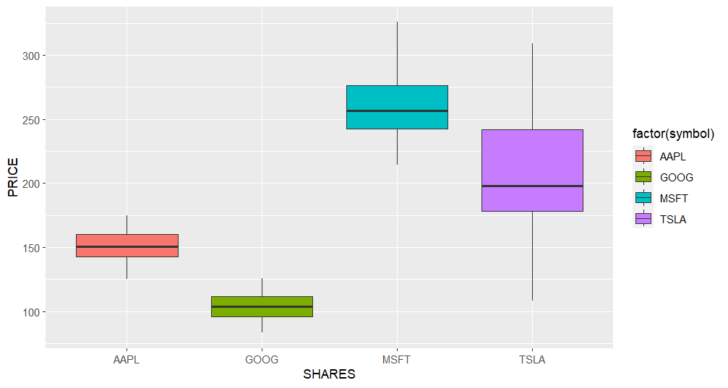

* 1. **Analysis**
* Tesla Stock is more volatile than Apple, Google & Microsoft stocks.
* Microsoft stock is positively skewed.
* Google stock is normally distributed.

1. **Visualization – Candlestick & 20 days moving average of Apple Stock.**

**RCODE**

apple_stock <- stock_data %>%

filter ( symbol == "GOOG") %>%

mutate(moving_average = zoo:: rollmean(close, k = 20, fill = NA, align = 'right'))

apple_stock

candle_chart <- ggplot (apple_stock, aes(x = date))+

geom_candlestick(aes(open = open, high = high, low = low, close = close) )+

geom_line(aes(y = moving_average), color ='black')+

ylab('Price')

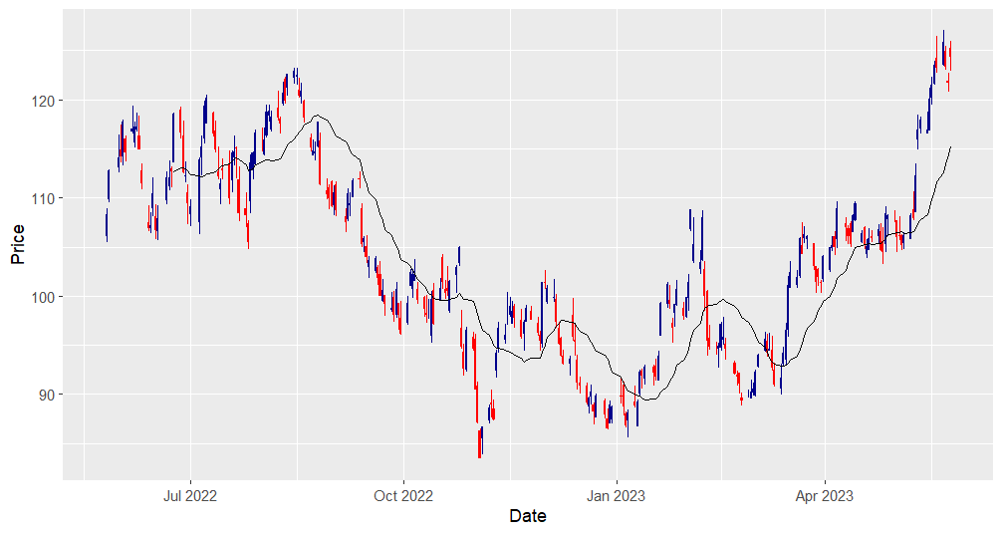

* 1. **Analysis**
* Apple Stock is trading above the closing price.
* Apple is trading at resistance level.

1. **Visualization – Linear relationship of Apple & Google Stock.**

**RCODE**

scatter_plot <- stock_data %>%

select(date, close, symbol) %>%

spread(symbol, close)

point_graph <- ggplot(scatter_plot, aes(x = AAPL, y = GOOG)) +

geom_point()+

geom_smooth(method = 'lm', se = FALSE)

point_graph

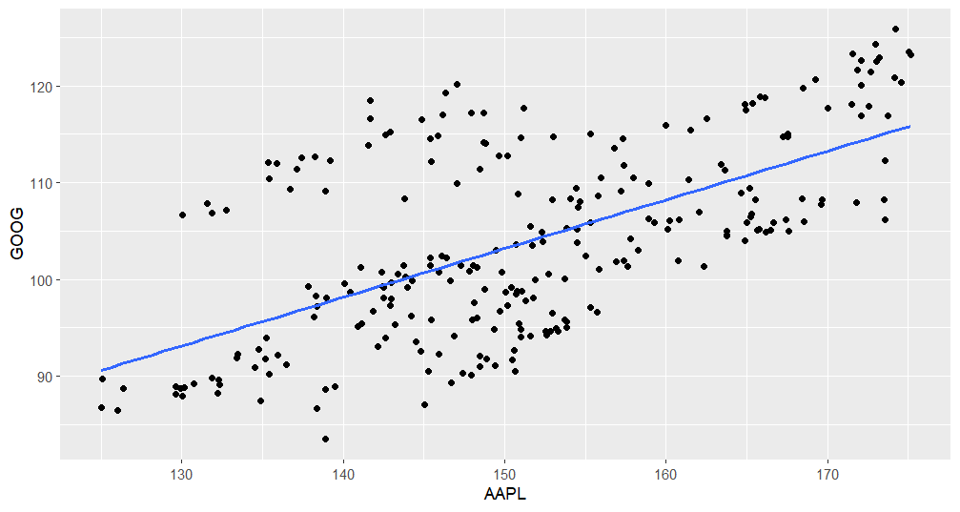

* 1. **Analysis**
* Apple Stock & Google Stock both are positively related.